COMPUTER MODELING OF CAVE PASSAGES

By Larry Fish

Since the 1960’s, computers have been used to generate line plots of caves. A line plot is the simplest form of cave map, showing only the lines that trace the survey shots through the cave. While A line plot is easy to generate and illustrates the general layout and structure of a cave, it shows nothing about size and shape of the passages. To truly understand the geology, hydrology, and origins of a cave, you need to be able to see the size, shape and orientation of the rooms and passages. This article explores some ideas and new techniques for creating good passage models on computers.

In the early days of cave surveying, surveyors took measurements of the passage dimension primarily to help cartographers draw maps. With the advent of the personal computer, these measurements are increasingly used to create computer passage models. However, even with the power of today’s computers, it is surprisingly difficult to create pleasing and accurate passage models. Part of the problem is the way we collect survey data. Cave surveyors typically take four measurements of the passage outline at each shot. While this would be enough information if cave passages had a square cross section, it is not enough information to accurately portray the irregular shapes of real caves. To accurately model cave passages, we need more points. For example, instead of the four left, right, up and down (LRUDs) measurements, we probably need six or eight. Likewise, instead of only taking measurements at the ends of each shot, they should be taken at regular intervals, every few feet along the passage. Unfortunately, cave surveying is already a tedious task and it is not very likely that surveyors would be willing to gather more data. Collecting this kind of data is not likely to happen until we have computerized surveying tools that will automatically record this information.

Given that we don’t have a lot of information, we still should be able to create pleasing cave-like passage shapes. However, even this simple task is more difficult than it might seem. Let’s look at some of the issues.

TWO-DIMENSIONAL MODELS. We will start with two-dimensional models. Our goal is to create a computer map that looks reasonably like a hand-draw map.

Starting with the plan view, if you take a survey shot and the left and right dimensions at each station, you can draw a line on each side of the shot that approximates the position of the passage walls. You also may want to draw a line showing where the left-right measurements were taken. This will close the ends of shots, generally creating long, rectangular shapes.

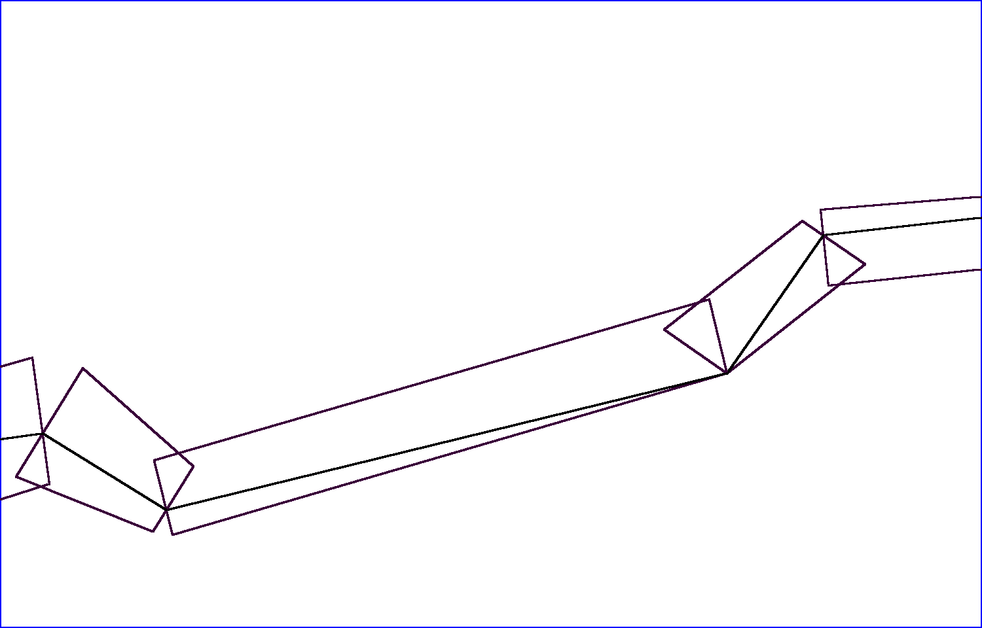
Figure 1 - Polygon Mode passages models, taken from the COMPASS Viewer.
As you can see, while this does approximate the passage shape, it is not very visually pleasing. The gaps and overlaps give it a confused, disjointed look.

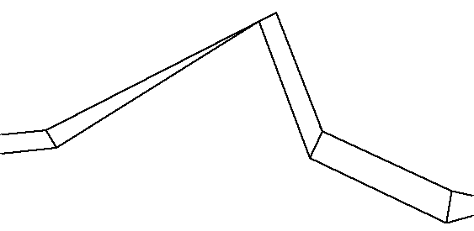
Figure 2 - Joined Polygon Mode, taken from the CaveX Viewer.
You can eliminate some of the disjointed appearance by joining the ends each shot together. This works well up to a point, but as you can see in Figure 2, when the angle between the two shots approaches 90°, the passages walls get closer together and the passage appears to kink like a garden hose. You can mitigate this problem slightly by adjusting the angle of the joint, but that just spreads the distortion to both shots. Even when the angle is not too acute, the corners have sharp edges that don’t look much like the smoothly curved walls of hand drawn maps or real caves.

SMOOTHING FUNCTIONS. One way to deal the disjointedness at the corners is to use a mathematical function to draw smoothly curving passage walls. Although there are many functions that will draw curved lines, the most useful are called Parametric Cubic Curves. These functions are particularly useful because they make it easy to control the shape of the curve. There are several different types of Cubic Curves and each one has a different method of controlling the shape. In COMPASS, I chose to use a variation of the Hermite Curve to draw passage walls.

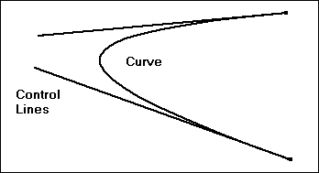
Figure 3 - Hermite Splines and Control Lines.

The Hermite Curve uses line segments to control how a line is curved. Normally, these control lines are hidden and only the curve is drawn, but the length and angle of the control lines govern how sharp and long the curve will be. In Figure 3, you can see how typical control lines might effect the shape of the curve.

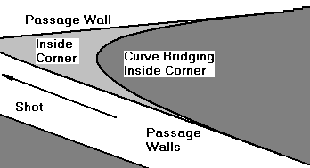
Figure 4 - Using passage walls as control lines.

It is easy to see how you could use parts of the passage walls as control lines to draw smooth curves around corners. Figure 4 illustrates the process of constructing control lines from passage wall lines. Here there are two connected shots that make a sharp right-hand turn. The right-hand passage walls are used as control lines and the curve bridges the inside corner forming a smooth transition between the two shots.

In actual practice, the process is more complicated. The biggest problem is that you have to deal with the inside of a corner differently than the outside.

1. Inside Corners. As the angle between two shots gets more acute, the lines forming the passage walls will overlap. If you use crossed lines as control lines, the function will draw a very unattractive loop at the corner. For this reason, you must truncate the lines some distance back from the corner to get a pleasing curve. Determining just where and how to truncate the lines can get pretty complicated.

2. Outside Corners. Outside corners suffer from a different problem. As the angle between two shots gets more acute, the outside curve tends to flatten until it cuts off part the corner. The solution to this is to extend the control lines beyond the end of the passages. The tricky part is to get the distance to extend the lines just right. Several parameters come into play including the width of the passage and the angle between the two shots.

All these adjustments to the control lines require quite a few calculations, but it is worth the trouble. The result is a pleasing passage model that looks similar to a hand-drawn map.

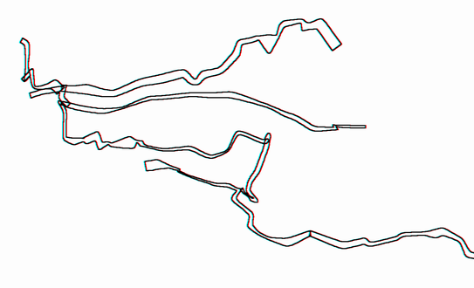
Figure 5 - Actual passages image from the COMPASS Viewer.

FILLED PASSAGES. Another useful feature is to fill the passage outlines with color. Usually this is done with some kind of flood filling routine. Even this can be tricky because if there are any gaps in the passage outline, the flood-fill will leak out and color the whole page. Filled maps are very useful because they give a simple, clear image of the cave and, since they can be printed in black and white, they work well for publication.

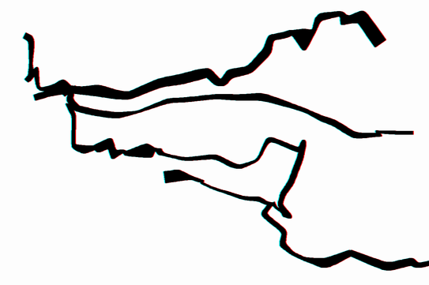
Figure 6 - Filled passage model. (Image from the COMPASS Viewer.)
THREE-D MODELS. So far, I have only described two-dimensional passage models. While they are very useful for paper maps, to truly appreciate the structure of a cave, you need a 3D model.

Generally speaking, 3D computer models are created using a grid of points that represent locations on the surface of an object. By connecting these points together, you create a series of faces that can be used by the computer to draw an image of the object.

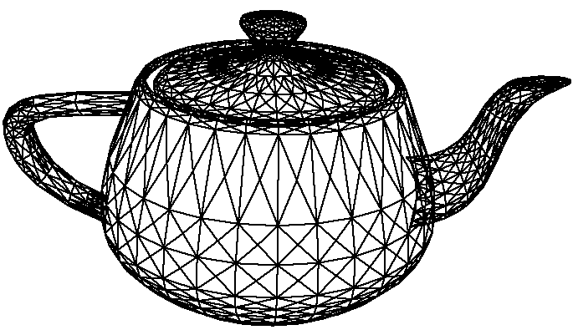
Figure 7 - Typical mesh of a three-dimensional object.

This collection of points and faces is called a mesh and, as you can see in Figure 7, it can be used to represent any three-dimensional object. The more faces, the smoother the object can be drawn.

CROSS SECTIONS. In the two-dimensional model, we started by drawing lines next to the shot that approximated the position of the passage walls. In the 3D model we want to draw a tube around the shot based on left, right, up and down dimensions. Since there are four measurements in each LRUD, it is very easy to generate a four-sided tube with a diamond or square cross section. However, more sides are needed to create a smooth surface. Given the four measurements, it is relatively easy to create octagonal cross sections.

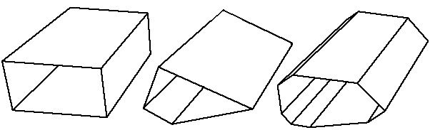
Figure 8 - Square, Diamond and Octagonal tubes. (Images from the CaveX Viewer.)

Figure 8 shows a square, diamond and octagonal cross sections using LRUDs of 3,10, 5 and 2 respectively. As you can see the octagonal shape more closely approximates the typical oval shape of a cave passage.

CORNERS. As in the 2D case, connecting two shots together by joining the tubes can be difficult. Using the cubic curves and dealing with inside and outside curves could be very complicated on a 3D object. As a result, I have developed a new technique that simulates the cubic curves; but is faster, simpler and gives very pleasing results.

NEW ALGORITHM. The process involves subdividing each corner into two smaller corners that smoothes the transition between shots. The process can be carried out repeatedly, with each successive round of subdivision further rounding the corner. The process works well with any inter-shot angle and doesn’t require any special handling of the inside or outside part of the corner. Another big advantage of this technique is that most of the work of rounding the corner is done with the two shot lines rather than two 3D solids.

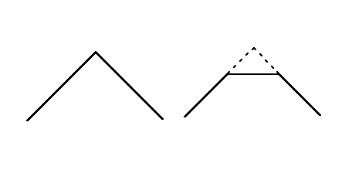
Figure 9 - Subdividing corners into three shot.

Figure 9 illustrates the process. The drawing on the left shows two shots connected at a 90° angle. The process begins by selecting a point a short distance from the corner on both shots. The shots are then truncated at these points and a new artificial shot is added, connecting the new end-points. New LRUDs are then generated for these new end-points by linearly interpolating from the original values. You now have three shots where there were originally two and the LRUDs for the new shot smoothly transitions between the original two. All the math is carried on the shot lines and LRUDs, and you don’t have to deal with 3D objects until the passages are drawn.

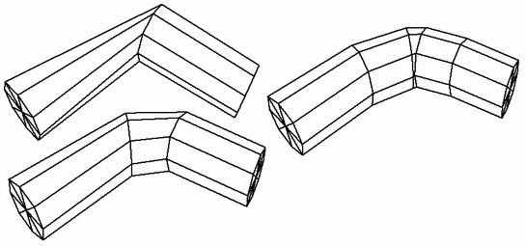
Figure 10 - Subdividing 3D passage. (From the CaveX Viewer.)

Figure 10 shows a simple, two shot sequence that has been rendered as an octagonal tube. In the first image, no corner rounding has been done. Here the tube has been flattened by the sharp angle at the corner. The second image shows how the passage looks after it has been subdivided once, generating three shots. In this image, the angles between shots are much less acute. Finally, in the last image, the shots have been subdivided twice, generating a total five shots. Having five shots in place of two, opens the angle between shots and makes a smooth transition around the corner. (Note: these artificial shots are not actually inserted into the cave data, they just generated temporarily to create the mesh.)

Once the passage has been converted into a mesh, further smoothing can be accomplished by splitting the rectangles in to triangles and creating more faces. The tradeoff is that more faces put greater the demand on memory resources and processor power.

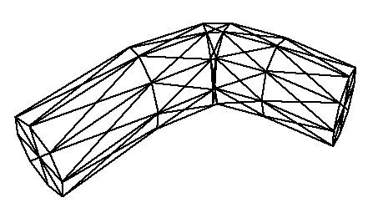
Figure 11 - Increasing the number of faces. (CaveX Viewer.)

To give you an example of the mesh sizes we are dealing with, rendering Lechuguilla Cave, which is about 100 miles long, requires about 500,000 polygons and 180 megabytes of memory. This is with one pass of corner rounding and no other smoothing. This may sound like a lot, but a 450 MHz Pentium III and an accelerated video card can display more than 2 millions polygons per second. This gives animation rates of five or six frames per second, more than adequate to manipulate and animate the image in real-time.

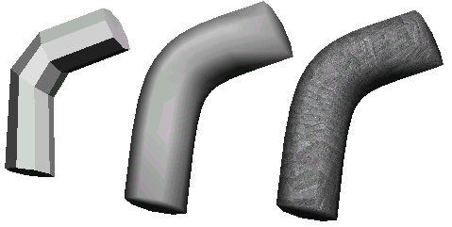
Figure 12 - Filled, Smoothed and Texture passage segment. (CaveX Viewer.)
Although the mesh now approximates the shape of a cave, the flat faces give it a unnatural faceted appearance. The final step uses illumination, shading and texturing to further smooth the object. The illumination and shading process mathematically simulates the way light reflects off of the surface of an object. The first image in Figure 12 illustrates the first step in this process. Here, each face in the mesh is filled with color whose brightness varies according the amount of light reflected off each face. Because each face has the same brightness across its whole surface, the faces appear flat and make the object look faceted. In the second image, we have used a technique to eliminate the faceted appearance. Here the brightness changes across the surface of each face, smoothly grading from edge to edge. This makes the faces disappear and gives the appearance of a smooth, tubular surface. The method used here is called Gourad Shading. By changing the parameters of the shading process, you can vary the appearance of the surfaces from a soft matte finish to a glassy finish like polished steel.

Another thing that can improve the appearance is to overlay the surface with a texture. Texturing takes a bitmap image and overlays it on the surface of the object. In the final image above I have taken a photograph of a limestone boulder and stretched it over the cave passage. This gives it a rock-like appearance more consistent with cave walls.

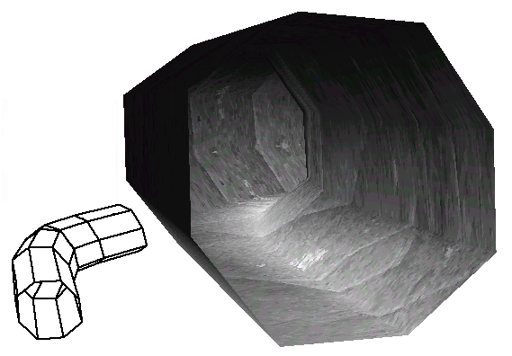
Figure 13 - Passage interior, using spot lighting and texturing. (CaveX Viewer.)

So far, we have been viewing the cave from the outside but there is no reason they cannot be viewed from inside as well. With advanced illumination techniques, you can even simulate the effects of a caver’s helmet light on the passage walls. Figure 13 shows the combination of two techniques on the interior walls. Here the walls are painted with a limestone texture and the tunnel is illuminated with a spotlight aimed down the passage.

The techniques used to do illumination, shading and texturing are covered in detail in any textbooks on computer graphics. However, modern graphic cards are capable of carrying out all these operations in hardware, greatly accelerating the display. Since every graphics card has its own proprietary techniques of hardware acceleration, most programmers use a graphic language such as Microsoft’s DirectX or Sun Microsystem’s OpenGL to access these special features.

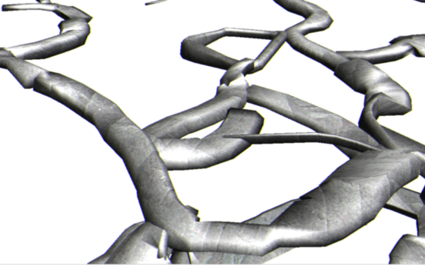
Figure 14 - View of fully rendered cave passages. (CaveX Viewer.)

Figure 14 shows the finished product. Here, all the techniques described in this article are used to show passages in the Chocolate High section of Carlsbad Cavern. Using DirectX or other similar technology, even these very complex images can be manipulated at very high speed.

The Future. Many of the techniques described in this article would be unnecessary if we collected better data. In addition to collecting more data points, the most pressing need is to change the way we deal with vertical or steeply sloping shots. Currently, there is no standard way of making measurements in a vertical or near vertical passage. Obviously, the concept of making up, down, right and left measurements is meaningless on a steeply angled shot. Currently, only Toporobot, a Swiss cave survey program, has a clearly defined standard for dealing with vertical shots and steeply sloping passages. Unfortunately, this standard is so different from the way the rest of the world surveys, that it probably won’t be widely adopted. It is certainly incompatible with the thousands of miles of survey data already in our computers.

SOFTWARE. All the images in this article were generated in COMPASS, a cave survey software package. For more images of caves and passage wall models refer to the COMPASS web page at: http://fountainware.com/compass

The Hermite curve was chosen because of its obvious applicability to the task at hand. Other cubic curves might work as well or better, but some of experimenting and coding would be necessary to find out.
This plot is taken from Fixin’ To Die Cave, in Western Colorado.
One of the best texts covering the whole field of computer image rendering is Computer Graphics, Principles and Practice by Foley, vanDam, Feiner and Hughes. Addison Wesley

